A Project Report On
Raspberry Pi Based Vehicle Starter Using Face Detection
Submitted in partial fulfilment of the Requirement for the award of the degree of
Bachelor of Technology In
ELECTRONICS AND COMMUNICATION ENGINEERING
Submitted By

P. VISHNU VARDHAN (22HN1A0443) CH. DILEEP (22HN1A0407) CH. VENKATA SRIRAM (22HN1A0402) V. ADHITYA (22HN1A0466)
Under the guidance of Mr. A. Devamani, M. Tech, (Ph.D.)
Associate professor, Dept of ECE


DEPARTMENT OF ELECTRONICS AND COMMUNICATION ENGINEERING

ANDHRA ENGINEERING COLLEGE
(Affiliated to JNTUA, Anantapur, &Approved by AICTE, New Delhi.)
NELLORE PALEM, ATMAKUR-524322.
Batch: 2022-2026

DEPARTMENT OF ELECTRONICS AND COMMUNICATION ENGINEERING
ANDHRA ENGINEERING COLLEGE
(Affiliated to JNTUA, Anantapur &Approved by AICTE, New Delhi.)
NELLORE PALEM, ATMAKUR-524322.



CERTIFICATE
This is to certify that the major project report entitled "RASPBERRY PI BASED VEHICLE STARTER USING FACE DETECTION" that is being submitted by P.VISHNU VARDHAN (22HN1A0443), CH. DILEEP (21HN1A0407), CH. VENKATA SRIRAM (22HN1A0402), V.
ADHITYA (22HN1A0466) of Bachelor of Technology in Electronics and Communication Engineering to the Jawaharlal Nehru Technological University Anantapur, Anantapur is a record of bonafide work carried out for the academic year 2022-2026.

Internal Guide Head of the Department
Mr. A. DEVAMANI, M. Tech, (Ph.D) Mr. A. DEVAMANI, M. Tech, (Ph.D)
Associate professor, ECE Dept., Associate professor, ECE Dept.,

External Viva Voce Conducted on

Internal Examiner External Examiner

ACKNOWLEDGEMENT

We are very thankful to our guide Mr. A. DEVAMANI, M. Tech, (Ph.D)., Department of Electronics and Communication Engineering, for her support and guidance which made me to complete the work successfully.
Our sincere thanks to the Management of Andhra Engineering College, for providing excellent infrastructure and lab facilities that helped us to go through the different areas of interest to do our major project.
It is our privilege and pleasure to express profound sense of respect, gratitude and indebtedness to Dr. P. GOVARDHAN Ph .D, Principal for guiding and providing facilities for the successful completion of major project.
We sincerely thank to Mr. A. DEVAMANI, M. Tech, (Ph.D)., Head of the Department, for his valuable support and constant encouragement given to us during this work.
We express our deep sense of gratitude to the Major project Coordinator, Ms. D. SHALINI KRISHNA MTech., for supporting and encouraging us at each stage of our major project work and instructed us to do the best.
We extend our sincere thanks to all the teaching and non-teaching staff members of the Department of The Electronics and Communication Engineering.
Finally, we wish to acknowledge our parents and friends for giving moral strength and encouragement.
P. VISHNU VARDHAN 22HN1A0443 CH. DILEEP 22HN1A0407 CH. VENKATA SRIRAM 22HN1A0402
V. ADHITYA 22HN1A0466

ABSTRACT
This project presents a Raspberry Pi-based face recognition system designed for secure vehicle engine unlocking. The system integrates advanced biometric authentication using OpenCV for face detection and recognition with Raspberry Pi for hardware control.
The laptop handles computationally intensive image processing tasks, while the Raspberry Pi manages engine control through relay modules, visual indicators (LEDs), audible alerts (buzzer), and an I²C LCD display.
The system ensures that only authorized users can unlock and start the vehicle engine, providing enhanced security against unauthorized access. When an authorized face is recognized, the engine is unlocked; otherwise, the system triggers security alerts including visual and audible warnings. This dual-component architecture optimizes performance by distributing processing loads effectively, ensuring real-time response and high accuracy in face recognition

TABLE OF CONTENTS

TITLES | PAGE NO
ABSTARCT | 1
TABLE OF CONTENTS | 2-5
LIST OF FIGURES | 6
LIST OF TABLES | 7
CHAPTER-1 INTROCUCTION | 7-8
1.1 Introduction to embedded systems | 7
1.2 Purpose of the project | 8
1.3 Objective of the project | 8
1.4 Scope of the project | 8
CHAPTER-2 METHODOLOGY | (9-11)
2.1.1 System Initialization | 9
2.1.2 Face Detection And recognition Process | 9
2.1.3 Authorised User Operation | 9
2.1.4 Unauthorised User Operation | 9
2.1.5 Load Distribution and Optimization | 10
2.2 Proposed system block diagram | 10-11
CHAPTER-3 HARDWARE TOOLS | (12-30)
3.1 Introduction | 12
3.1.1 Chip nomenclature | 12
3.2 Key Features &Specifications | 13
3.2.1 Processor Architecture | 13
3.2.2 Memory subsystem | 13
3.2.3 Peripheral set | 13
3.2.4 Clocking and power | 13
3.3 System Architecture | 14
3.3.1 Bus Fabric and connectivity | 14
3.3.2 Bus priority system | 14
3.3.3 Atomic register access | 14
3.4 Memory Organization | 15
3.5 Programmable I/O (PIO) | 15
3.5.1 PIO capabilities | 15
3.5.2 PIO use cases | 16
3.6 Power Management | 16
3.6.1 Power supply architecture | 16

    - Low power modes 16
    - Power consumption characteristics 17
  - USB Capabilities 17
    - USB Features 17
    - Bootloader functionality 17
  - ADC and Analog capabilities 18
    - ADC specifications 18
    - Temperature sensor 18
  - Clock System 18
    - Clock sources 18
    - Phase Locked Loops (PLLS) 19
    - Clock Generators 19
  - DMA Controller 19
    - DMA Features 19
    - Common DMA use cases 20
  - Debug and development 20
    - Serial wire debug (SWD) 20
    - Boot modes 20
    - Development Tools 20
  - Package and Pin Configuration 21
    - Physical package 21
    - GPIO Pin functions 21
    - Pin electrical characteristics 21
  - Conclusion and Recommendations 21
    - Summary of capabilities 21
    - Ideal applications 22
    - Design considerations 22
    - Future considerations 22
    - References 22
  - Laptop Camera 23
  - Relay module 23
    - Main components of the relay module 23
    - Function in the system 24
  - I2C LCD Display(16*2) 24-25
  - LED Indicators 25
  - Buzzer 26

3.18.1 Piezo electric | 26
3.18.2 Electromechanical | 27
3.18.3 Mechanical | 27
3.19 Power supply | 27
3.20. Communication Interface | 27
3.21. DC Gear Motors | 27-28
3.21.1 Introduction | 29
3.21.2 Connecting DC motors with microcontroller | 29
3.21.3 Connecting wires and bread board | 30
CHAPTER-4 SOFTWARE TOOLS | (31-39)
4.1 Introduction | 31
4.2 Python programming language and open CV | 31
4.2.1 Advantages of Python | 31
4.2.2 Advantages of OpenCV | 32
4.3 Installation of python and open CV | 32
4.4 Raspberry Pi Pico and C language | 32-33
4.5 Pico SDK and Development process | 34
4.6 Communication between laptop and Pico | 34
4.7 conclusion | 35
4.8 Advantages | 35-36
4.9 Applications | 36-38
CHAPTER-5 EXPERIMENTAL RESULTS | (39-41)
CHAPTER-6 CONCLUSION AND REFERENCES | (42-43)
6.1 Conclusion | 42
6.2 References | 42-43

 | LIST OF FIGURES
FIG NO | NAME OF THE FIGURE | PAGE NO
2.1 | Block Diagram | 11
3.1 | Pin Diagram of Raspberry Pi Pico | 13
3.2 | Relay Module | 24
3.3 | I2C LCD Display | 26
3.4 | LED Indicators | 27
3.5 | Buzzer | 28
3.6 | Brushless DC Motors Working | 30
3.7 | DC Geared Motor | 30
3.8 | Pin Diagram L293D Microcontroller | 31
4.1 | Importing python open CV | 33
4.2 | Raspberry Pi Pico Coding | 35
4.3 | Visual Studio For Code Development | 37
5.1 | Authorized User And Engine ON | 40
5.2 | Unauthorized Used And Access Denied | 41

LIST OF TABLES
TABLE NAME PAGE NO
Table 3.1 Memory Organization 16

CHAPTER-1 INTRODUCTION
  - Introduction to embedded system

To improve system reliability, the face recognition module is trained using multiple images of authorized users captured under different lighting conditions and facial orientations. This enhances recognition accuracy and reduces false acceptance or rejection. The system continuously monitors the captured video stream and compares detected faces with the stored database. If a match is found, an authentication signal is sent to the control unit to enable vehicle ignition. If the face is not recognized, the system keeps the engine disabled and can optionally trigger an alert mechanism such as a buzzer or notification.

The hardware interface plays a crucial role in ensuring secure and smooth operation. The Raspberry Pi communicates with a relay module that controls the vehicle’s ignition system. When authentication is successful, the relay is activated, allowing current flow to the motor or ignition circuit. Status LEDs provide visual feedback indicating whether access is granted or denied. This layered feedback mechanism enhances user interaction and system transparency.

Another important feature of the proposed system is its scalability and adaptability. Additional biometric factors such as password verification or mobile-based authentication can be integrated to create a multi-factor security system. The modular design also allows easy upgrades in both software and hardware components without requiring major system redesign. This flexibility makes the system suitable not only for personal vehicles but also for fleet management and restricted-access transportation systems.

From a practical implementation perspective, the system is designed to be cost-effective and energy efficient. By delegating complex processing tasks to a laptop and using the Raspberry Pi solely for control operations, the overall hardware requirement is optimized. The use of widely available components ensures affordability and ease of maintenance. Furthermore, the system can operate in real-time with minimal latency, ensuring a seamless user experience.

In conclusion, the face recognition-based vehicle security system provides a modern and reliable alternative to traditional access methods. By combining biometric authentication with embedded control technology, the system enhances protection against unauthorized usage

while maintaining user convenience. Its distributed architecture, real-time performance, and extensibility make it a practical solution for next-generation intelligent vehicle security systems.
  - Purpose of the Project
The purpose of this project is to enhance vehicle security by replacing traditional key-based access with a face recognition authentication system. The system ensures that only authorized users can start and operate the vehicle, thereby reducing the risk of theft and unauthorized usage. By combining real-time image processing with reliable hardware control, the project aims to provide a smarter, safer, and more efficient vehicle access solution.

  - Objective of the Project
The main objective of this project is to design and implement a face recognition-based vehicle control system using a laptop for image processing and a Raspberry Pi for hardware operation. The system aims to detect and recognize faces in real time, verify authorized users, and control vehicle functions such as engine activation through relay mechanisms. It also seeks to achieve high accuracy, fast response time, and reliable performance in real-world conditions.

  - Scope of the Project
The scope of this project includes the development of a secure biometric authentication system for vehicles using face recognition technology. It covers real-time face detection, user verification, and hardware control integration. The system can be applied in personal vehicles, smart transportation systems, and security-sensitive environments. Future enhancements may include cloud-based data storage, mobile application integration, and support for multiple biometric authentication methods.

CHAPTER-2 METHODOLOGY
  - METHODOLOGY
- The system captures real-time video via a Raspberry Pi camera and utilizes OpenCV
To detect and compare the driver's face against a registered database.
2.1.1System Initialization
      - The laptop is powered ON and the OpenCV-based face recognition program is launched.
      - The Raspberry Pi is powered ON along with the relay module, I²C LCD, buzzer, and status LEDs.
      - A communication link (serial/USB/wireless) is established between the laptop and the Raspberry Pi.
    - Face Detection and Recognition Process
      - The laptop's built-in camera continuously captures live video frames.
      - OpenCV performs face detection using a trained Haar Cascade algorithm.
      - Once a face is detected, face recognition is performed by comparing the detected face with a pre-trained database of authorized users.
      - The recognition algorithm determines whether the detected face matches an authorized user.
    - Authorized User Operation
- When the detected face matches an authorized user:
- The OpenCV program generates an authorization signal.
- The laptop sends an 'ENGINE ON' command to the Raspberry Pi via the communication interface.
- The Raspberry Pi activates the relay module, which unlocks and turns ON the vehicle engine.
- A green LED is turned ON to indicate successful authentication.
- The I²C LCD displays: 'Authorized User - Engine ON'.
- The engine remains ON as long as the authorized condition is maintained.

    - Unauthorized User Operation
When the detected face does not match any authorized user:
      - The laptop sends an 'UNAUTHORIZED' alert command to the Raspberry Pi.
      - The engine remains locked (relay stays OFF).
      - A red LED is turned ON to indicate unauthorized access.
      - The buzzer is activated to alert nearby people.
      - The LCD displays: 'Unauthorized Access Detected'.

    - Load Distribution and Optimization
      - All image processing tasks (video capture, face detection, recognition) are handled by the laptop, which has higher computational capability.
      - The Raspberry Pi is used only for decision execution and hardware control, reducing processing load.
      - This separation improves accuracy, reliability, and real-time performance of the system.

2.2 PROPOSED SYSTEM BLOCK DIAGRAM

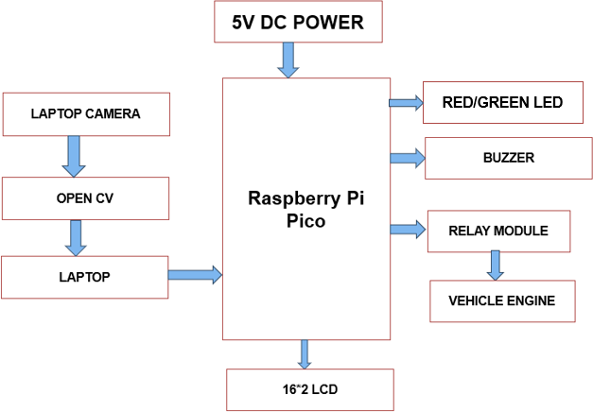

Fig 2.1: Block Diagram
The proposed face recognition–based vehicle security system enhances vehicle safety by integrating computer vision technology with embedded system control. The system operates using a 5V DC power supply and uses a laptop camera to capture the image of the person attempting to start the vehicle. The captured image is processed using OpenCV on the laptop, where facial features are detected and compared with a stored database of authorized users. After authentication, the result is sent to the Raspberry Pi Pico, which acts as the central control unit of the system. Based on the verification result, the microcontroller either allows or prevents the vehicle engine from starting. If the face is recognized as authorized, the system activates the engine and provides confirmation through visual display and indicators; if unauthorized, it blocks ignition and generates alert signals. This integration of face recognition and microcontroller-based control ensures secure, reliable, and efficient vehicle access, reducing the risk of theft and unauthorized usage while providing real-time feedback to the user.

The proposed face recognition–based vehicle security system enhances vehicle safety by integrating computer vision technology with embedded system control. The system operates using a 5V DC power supply and uses a laptop camera to capture the image of the person attempting to start the vehicle. The captured image is processed using OpenCV on the laptop, where facial features are detected and compared with a stored database of authorized users. After authentication, the result is sent to the Raspberry Pi Pico, which acts as the central control unit of the system. Based on the verification result, the microcontroller either allows or prevents the vehicle engine from starting. If the face is recognized as authorized, the system activates the engine and provides confirmation through visual display and indicators; if unauthorized, it blocks ignition and generates alert signals. This integration of face recognition and microcontroller-based control ensures secure, reliable, and efficient vehicle access, reducing the risk of theft and unauthorized usage while providing real-time feedback to the user.

CHAPTER-3

HARDWARE TOOLS
  - Raspberry Pi Pico

The RP2040 is Raspberry Pi's debut microcontroller, representing a significant entry into the embedded systems market. Designed with a focus on high performance, low cost, and ease of use, the RP2040 brings professional-grade capabilities to a wide range of applications from hobbyist projects to industrial automation.
Manufactured on a modern 40nm process node, the RP2040 delivers exceptional performance with low power consumption. Its stateless design with support for cached execute- in-place (XIP) from external QSPI memory allows developers to choose the appropriate storage density for their specific applications while benefiting from competitive Flash memory pricing.

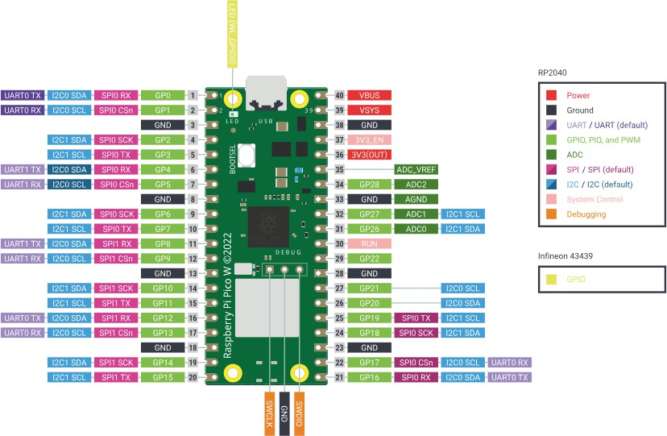

Fig 3.1: Pin Diagram Of Raspberry Pi Pico

    - Chip Nomenclature
The RP2040 designation follows a logical naming convention:
      - RP - Raspberry Pi prefix.

      - 2 - Number of processor cores (Dual-core).
      - 0 - Processor type indicator (Cortex-M0+).
      - 4 - RAM size indicator: floor(log2(RAM / 16kB)).
      - 0 - No onboard non-volatile storage.

  - Key Features and Specifications

    - Processor Architecture
      - Dual ARM Cortex-M0+ cores operating at up to 133MHz (overclockable to 200MHz at 1.15V).
      - Symmetric dual-core processor complex with independent execution.
      - Harvard architecture with separate instruction and data buses.
      - Full ARMv6-M instruction set support.

    - Memory Subsystem
      - 264kB on-chip SRAM divided into 6 independent banks.
      - Support for up to 16MB external Flash via dedicated QSPI interface.
      - 16kB Boot ROM with USB bootloader and utility functions.
      - XIP (Execute In Place) cache for improved Flash access performance.
      - Fully-connected AHB crossbar for parallel memory access.

    - Peripheral Set
      - 30 multifunction GPIO pins with flexible routing.
      - 2 × UART (Universal Asynchronous Receiver/Transmitter).
      - 2 × SPI (Serial Peripheral Interface) controllers.
      - 2 × I²C (Inter-Integrated Circuit) controllers.
      - 16 × PWM (Pulse Width Modulation) channels.
      - USB 1.1 controller with integrated PHY (Host and Device support).
      - 8 × PIO (Programmable I/O) state machines.
      - 4-channel 12-bit 500ksps ADC with internal temperature sensor.
      - 12-channel DMA controller.

    - Clocking and Power
      - 2 × on-chip PLLs for USB and system clocks.
      - Crystal oscillator supporting 1-15MHz crystals (12MHz recommended).
      - Ring oscillator for low-power operation.
      - On-chip voltage regulator (1.1V core from 1.8-3.3V input).
      - Multiple low-power modes: SLEEP and DORMANT.

      - Brown-out detection and power-on reset.

  - System Architecture
The proposed face recognition–based vehicle security system is designed with a layered system architecture that integrates software processing and hardware control units. The architecture consists of three main layers: the image acquisition layer, the processing layer, and the control/output layer. In the first layer, the laptop camera captures real-time images of the user attempting to access the vehicle. In the processing layer, OpenCV running on the laptop performs face detection and recognition by comparing the captured image with a pre-stored database of authorized users. The authentication result is then transmitted to the Raspberry Pi Pico through a communication interface such as serial or USB. In the control layer, the microcontroller interprets the received data and accordingly manages the ignition control mechanism and alert responses. This distributed architecture separates high-level image processing from low-level hardware control, ensuring better performance, reliability, and faster response. By combining computer vision algorithms with embedded system design, the architecture provides a secure, scalable, and efficient solution for modern vehicle access control systems.
    - Bus Fabric and Connectivity
The RP2040 employs a sophisticated bus fabric architecture centered around a 4:10 AHB-Lite crossbar. This design enables up to four simultaneous bus transfers per cycle, achieving a maximum sustained bandwidth of 2.0 GB/s at 125MHz system clock.
The four bus masters are:
      - Processor Core 0
      - Processor Core 1
      - DMA Controller Read Port
      - DMA Controller Write Port

    - Bus Priority System
The crossbar implements a two-level priority scheme configurable per-master via the BUS_PRIORITY register. High-priority masters (level 1) are serviced before low-priority masters (level 0) when accessing the same slave simultaneously. Within the same priority level, round-robin arbitration ensures fair access.
    - Atomic Register Access
Each peripheral register block provides atomic register operations through address aliasing, eliminating the need for read-modify-write sequences in concurrent access scenarios:

      - Base + 0x0000: Normal read/write access
      - Base + 0x1000: Atomic XOR on write
      - Base + 0x2000: Atomic bitmask set
      - Base + 0x3000: Atomic bitmask clear

  - Memory Organization

- The RP2040 memory system is designed for maximum bandwidth and flexibility.

- The 264kB of on-chip SRAM is physically partitioned into six independent banks, allowing simultaneous parallel access from different bus masters.

Table 3.1: Memory Organization

Address Range | Size | Description
0x00000000 | 16kB | Boot ROM
0x10000000 | 16MB | Flash (XIP cached)
0x20000000 | 264kB | On-chip SRAM
0x40000000 | Variable | APB Peripherals
0x50000000 | Variable | AHB-Lite Peripherals
0xD0000000 | Variable | Cortex-M0+ Internal
  - Programmable I/O (PIO)
The RP2040's Programmable I/O (PIO) subsystem is one of its most distinctive features, providing unprecedented flexibility in implementing custom digital interfaces. Each PIO block contains 4 state machines, with 2 PIO blocks totaling 8 state machines system-wide.
    - PIO Capabilities

      - Cycle-accurate I/O timing independent of CPU execution.
      - 32 instructions per program, 9-bit instruction encoding.
      - Dedicated 4-deep TX and RX FIFOs per state machine.
      - Programmable clock divider (16-bit integer, 8-bit fractional).
      - DMA integration for zero-CPU overhead data transfer.
      - Flexible GPIO mapping with up to 30 pins accessible.

    - PIO Use Cases
PIO state machines can implement a wide variety of interfaces that would traditionally require dedicated hardware peripherals:
      - WS2812 (Neo Pixel) LED control with precise timing.
      - Additional UART, SPI, or I²C interfaces beyond built-in peripherals.
      - Manchester and Differential Manchester encoding.
      - Quadrature encoder interfaces.
      - Custom parallel bus protocols.
      - DPI (Display Parallel Interface).
      - I²S audio interfaces.

  - Power Management

The power supply unit plays a critical role in ensuring the reliable functioning of the entire system by delivering a constant and noise-free DC output to all modules. It typically includes rectification, filtering, and voltage regulation stages to convert the available input power into a smooth and stable DC voltage suitable for electronic components. Proper filtering minimizes ripple content and electrical noise, which could otherwise interfere with sensitive operations such as image processing and microcontroller communication. Voltage regulators maintain a fixed output even when input voltage or load conditions vary, thereby preventing system instability or unexpected resets. Additionally, protection mechanisms such as overvoltage protection, short-circuit protection, and thermal shutdown safeguards the circuit from damage. A well-designed power supply not only improves efficiency and durability but also enhances the overall reliability, accuracy, and lifespan of the vehicle security system.
    - Power Supply Architecture
The RP2040 requires multiple power supply rails for different subsystems:
      - IOVDD (1.8V - 3.3V): Digital I/O supply.
      - DVDD (1.1V): Digital core supply.
      - VREG_VIN (1.8V - 3.3V): Voltage regulator input.
      - VREG_VOUT (1.1V, 100mA max): Voltage regulator output.
      - USB_VDD (3.3V): USB PHY supply.
      - ADC_AVDD (3.3V): ADC analog supply.

Low-Power Modes

- SLEEP Mode
In SLEEP mode, processor execution is halted while peripherals continue to operate. The

processor can be woken by any interrupt. This mode is suitable for applications requiring quick wake-up response with moderate power savings.
- DORMANT Mode
DORMANT mode achieves the lowest power consumption by stopping all clocks, including the ring and crystal oscillators. The chip can only be woken by specific events such as GPIO edge detection or RTC alarm. This mode is ideal for battery-powered applications with infrequent activity.

Power Consumption Characteristics
Typical power consumption varies significantly based on operating mode and peripheral usage:
      - Active (125MHz, both cores): ~30mA @ 3.3V.
      - Active (125MHz, single core): ~20mA @ 3.3V.
      - SLEEP mode: ~10mA @ 3.3V.
      - DORMANT mode: <1mA @ 3.3V.

USB Capabilities
The RP2040 includes a full-featured USB 1.1 controller with integrated PHY, supporting both device and host modes. The USB subsystem requires a 27Ω series termination resistor on each data line (USB_DP and USB_DM), but pull-up and pull-down resistors are provided internally.

USB Features
      - Full Speed (12 Mbps) device mode.
      - Full Speed (12 Mbps) and Low Speed (1.5 Mbps) host mode.
      - 16 endpoints (8 IN, 8 OUT) in device mode.
      - 4kB USB data buffer RAM.
      - Integrated USB bootloader in ROM.

Bootloader Functionality
The ROM bootloader provides two USB interfaces for programming and debugging:
      - USB Mass Storage: Appears as a USB drive for drag-and-drop UF2 file programming.
      - PICOBOOT: Vendor-specific interface for advanced debugging and programming via Pico tool.
      - The RP2040 incorporates a 12-bit 500ksps SAR (Successive Approximation Register) ADC with 4 external input channels and an internal temperature sensor channel.

ADC and Analog Capabilities
The RP2040 incorporates a 12-bit 500ksps SAR (Successive Approximation Register) ADC with 4 external input channels and an internal temperature sensor channel.

ADC Specifications
      - Resolution: 12 bits (4096 levels).
      - Sample rate: Up to 500ksps.
      - Input voltage range: 0V to ADC_AVDD (typically 3.3V).
      - ENOB (Effective Number of Bits): ~8.7 bits typical.
      - Input channels: GPIO26-29 (ADC0-ADC3) plus temperature sensor.
      - Round-robin sampling mode for sequential channel measurement.
      - DMA support for continuous data capture.

Temperature Sensor
The integrated temperature sensor provides on-die temperature measurement with typical accuracy of ±2°C across the operating range. The sensor requires calibration using trim values stored in one-time programmable (OTP) memory for accurate absolute temperature readings.

Clock System
The RP2040 features a flexible clock generation and distribution system designed to provide precise timing for all system components while optimizing power consumption.

Clock Sources

The system supports two clock sources: the Crystal Oscillator (XOSC) and the Ring Oscillator (ROSC). The XOSC operates with external crystals in the 1–15 MHz range, with 12 MHz recommended for USB applications, offering high accuracy and programmable startup delay. The ROSC is an internal 6.5 MHz oscillator that requires no external components and consumes low power. Although less accurate than XOSC, the ROSC is suitable for low-power operations and random number generation.
- Crystal Oscillator (XOSC)
The external crystal oscillator accepts crystals in the 1-15MHz range, with 12MHz being the recommended frequency for USB applications. The oscillator includes programmable startup delay and can be configured for various crystal load capacitances.
- Ring Oscillator (ROSC)
The internal ring oscillator provides an approximate 6.5MHz clock source that requires

no external components. While less accurate than the crystal oscillator, the ROSC is useful for low-power applications and can serve as a random number generator source.

Phase-Locked Loops (PLLs)
Two independent PLLs multiply the crystal oscillator frequency to generate higher-frequency clocks:
      - PLL_SYS: Generates the system clock (typically 125MHz or 133MHz).
      - PLL_USB: Generates the fixed 48MHz USB reference clock.

PLL configuration follows the formula: Output = (Input × FBDIV) / (POSTDIV1 × POSTDIV2)

Clock Generators
Multiple clock generators distribute and divide clocks to various system components:
      - CLK_SYS: Main system clock feeding processors and most peripherals.
      - CLK_PERI: Peripheral clock for UART, SPI, I²C, PWM.
      - CLK_USB: 48MHz clock for USB controller.
      - CLK_ADC: ADC sampling clock.
      - CLK_RTC: Real-time clock (typically 46.875kHz).
      - CLK_REF: Reference clock for watchdog and system timer.

DMA Controller
The Direct Memory Access (DMA) controller enables autonomous data transfer between memory and peripherals without CPU intervention. With 12 independent channels, the DMA controller can significantly reduce CPU overhead in data-intensive applications.

DMA Features
      - 12 independent DMA channels.
      - Separate read and write bus master ports on the main crossbar.
      - Transfer sizes: 8, 16, or 32 bits.
      - Address increment, decrement, or no-change modes.
      - Peripheral-paced transfers using DREQ (Data Request) signals.
      - Channel chaining for complex transfer sequences.
      - Ring buffer mode for circular data structures.
      - Byte/halfword packing for efficient memory use.

Common DMA Use Cases

      - High-speed SPI data transfer.
      - UART bulk data transmission and reception.
      - ADC continuous sampling with automatic buffer management.
      - PWM waveform generation from memory buffers.
      - PIO data streaming for custom protocols.
      - Memory-to-memory block copies and fills.

Debug and Development

Serial Wire Debug (SWD)
The RP2040 implements ARM's Serial Wire Debug protocol via dedicated SWCLK and SWDIO pins. SWD provides comprehensive debug capabilities including:
      - Simultaneous debugging of both processor cores.
      - Four hardware breakpoints per core.
      - Two watchpoints per core.
      - Single-step execution.
      - Full register and memory access.
      - System trace via single-pin SWO (optional).

Boot Modes
The RP2040 supports multiple boot modes selected at power-on:
      - Normal boot: Execute from Flash via XIP.
      - USB boot: Enter bootloader mode (BOOTSEL button held during reset).
      - UART boot: Program via UART interface (if no valid Flash detected).

Development Tools
The RP2040 ecosystem includes comprehensive development tools:
      - Raspberry Pi Pico SDK (C/C++).
      - Micro Python and Circuit Python.
      - Arduino IDE support.
      - Pico tool: CLI utility for programming and inspection.
      - Pio assembler: PIO assembler and simulator.
      - Open OCD: Open-source debug adapter support.

Package and Pin Configuration

Physical Package

The RP2040 is available in a 7mm × 7mm QFN-56 package with the following characteristics:
      - Package type: QFN-56 (Quad Flat No-leads).
      - Dimensions: 7mm × 7mm × 0.9mm.
      - Pin pitch: 0.4mm.
      - Exposed pad: 3.2mm × 3.2mm (thermal and ground).
      - Operating temperature: -40°C to +85°C.
      - Storage temperature: -40°C to +125°C.

GPIO Pin Functions
Each of the 30 GPIO pins supports multiple functions selectable through software:
      - F1: SPI (Serial Peripheral Interface).
      - F2: UART (Universal Asynchronous Receiver/Transmitter).
      - F3: I²C (Inter-Integrated Circuit).
      - F4: PWM (Pulse Width Modulation).
      - F5: SIO (Software-controlled I/O).
      - F6/F7: PIO0/PIO1 (Programmable I/O).
      - F8: USB (VBUS detection, overcurrent detection).
      - F9: Clock I/O (GPOUT/GPIN).

Pin Electrical Characteristics
      - I/O voltage range: 1.8V to 3.3V (IOVDD).
      - Maximum output current: 12mA per pin (8mA recommended).
      - Input voltage tolerance: 3.63V maximum (IOVDD + 0.3V).
      - Programmable pull-up/pull-down resistors: 50kΩ - 75kΩ typical.
      - Programmable drive strength: 2mA, 4mA, 8mA, 12mA.
      - Schmitt trigger inputs with programmable enable.

Conclusion and Recommendations

Summary of Capabilities
The RP2040 microcontroller represents a compelling solution for embedded systems development, combining professional-grade features with accessibility and cost-effectiveness. Its dual-core architecture, extensive peripheral set, and unique Programmable I/O subsystem

make it suitable for a wide range of applications from simple sensor interfaces to complex industrial control systems.

Ideal Applications
      - Industrial automation and control systems.
      - IoT edge devices and sensor networks.
      - Audio processing and synthesis.
      - Motor control and robotics.
      - Display controllers and LED systems.
      - USB-based peripherals and accessories.
      - Educational platforms and maker projects.
      - Rapid prototyping and proof-of-concept development.

Design Considerations
When implementing RP2040 in new designs, consider the following recommendations:
      - Always use a 12MHz crystal for USB applications.
      - Provide adequate power supply decoupling (0.1µF + 10µF per supply).
      - Include proper 27Ω series resistors on USB data lines.
      - Implement BOOTSEL button for development/programming ease.
      - Connect SWD interface for debugging access.
      - Follow thermal design guidelines for reliable high-performance operation.
      - Use external Flash memory appropriate for application requirements (2-16MB).

Future Considerations

The RP2040 ecosystem continues to evolve with ongoing software updates, enhanced libraries, and growing community support. Regular monitoring of the official Raspberry Pi documentation and community forums will ensure access to the latest improvements, bug fixes, and application examples.
The combination of robust hardware capabilities, comprehensive development tools, and extensive documentation makes the RP2040 an excellent choice for both professional development and educational purposes.

References
      - RP2040 Datasheet, Raspberry Pi Ltd., February 2025.
      - Raspberry Pi Pico Datasheet, Raspberry Pi Ltd.
      - Getting Started with Raspberry Pi Pico, Raspberry Pi Press.

      - ARM Cortex-M0+ Technical Reference Manual, ARM Limited.
      - Raspberry Pi Pico C/C++ SDK Documentation.

  - Laptop Computer
The laptop serves as the primary computing unit for image processing and face recognition. It
must have sufficient processing power to run OpenCV algorithms in real-time. Specifications
include a multi-core processor (Intel i5 or higher), minimum 4GB RAM, built-in webcam, and USB/serial communication ports.

Relay Module
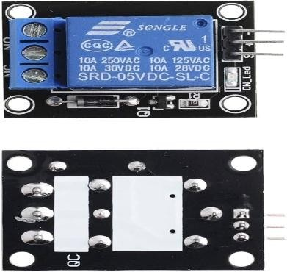
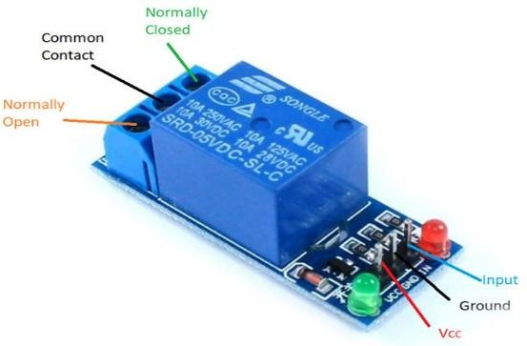

Fig 3.2: Relay Module

A 5V single-channel relay module is used in this system to control the vehicle engine ignition circuit. The relay acts as an electrically operated switch that allows a low-power signal from the Raspberry Pi GPIO pin to control a high-power engine ignition circuit safely.

The relay module provides electrical isolation between the Raspberry Pi and the vehicle’s ignition system, protecting sensitive electronics from high voltage and current. When an authorized signal is received from the RF receiver and processed by the control unit (Raspberry Pi), a HIGH or LOW signal is sent to the relay input pin (IN). This energizes the relay coil and switches the internal contacts from the Normally Open (NO) state to the Closed (COM-NO connected) state.

When the relay contacts close, the ignition circuit is completed, allowing current to flow and enabling the engine to start. When the relay is deactivated, the contacts return to their default open state, disconnecting the ignition circuit and preventing unauthorized engine operation.

Main Components of the Relay Module

- Electromechanical relay switch (SRD-05VDC-SL-C).

- Driver transistor for GPIO signal amplification.
- Flyback diode for back-EMF protection.
- Optocoupler for electrical isolation (available in some modules).
- Input pin (IN), Power pin (VCC), and Ground pin (GND).
- Output terminals: Normally Open (NO), Normally Closed (NC), and Common (COM).

Function in the System

The relay module acts as an interface between the low-power Raspberry Pi control system and the high-power vehicle ignition system, ensuring safe, reliable, and secure engine control through authorized RF signals.

  - I²C LCD Display (16×2)

The I²C 16×2 LCD display is a commonly used output device in embedded systems for displaying text-based information. It consists of 16 columns and 2 rows, allowing a total of 32 characters to be displayed at a time. Unlike the traditional parallel LCD, the I²C version uses an I²C interface module, which reduces the number of required connection pins to just four: VCC, GND, SDA, and SCL. This simplifies wiring and makes it ideal for microcontrollers like the Raspberry Pi Pico.

The display is used to show system messages such as status updates, authentication results, or error notifications. It operates using standard I²C communication protocol, where the microcontroller sends data serially through the SDA (data line) and SCL (clock line). The I²C LCD improves circuit organization, reduces pin usage, and enhances overall system efficiency while providing clear and user-friendly visual feedback.
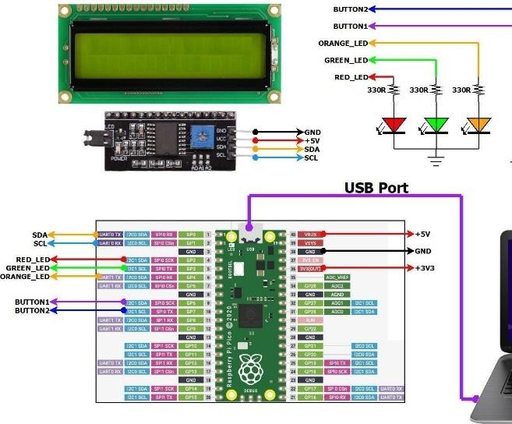
Fig 3.3: I²C LCD DISPLAY

The I²C LCD display (16×2 or 20×4) is used to provide real-time visual feedback to the user about the system status. It displays important messages such as "Authorized User – Engine ON", "Unauthorized Access Detected", and other system notifications.

The display communicates with the Raspberry Pi using the I²C communication protocol, which requires only two data lines:

- SDA (Serial Data Line)
- SCL (Serial Clock Line)

This significantly reduces the number of GPIO pins required compared to traditional parallel LCD interfaces, making the system simpler and more efficient.

The LCD module typically includes an I²C backpack controller (PCF8574), which converts I²C signals into parallel signals required by the LCD. This allows easy integration with microcontrollers and single-board computers like the Raspberry Pi.

Functions in the System

- Displays authentication status.
- Shows engine ON/OFF condition.
- Provides system alerts and warnings.
- Improves user interaction and system monitoring.

LED Indicators

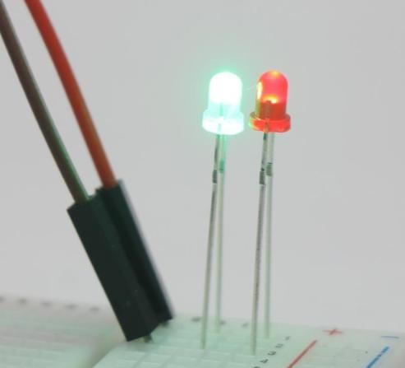
Fig 3.4: LED indicators

Two LED indicators are used in the system to provide quick visual status feedback.

- The Green LED indicates successful authentication and engine activation.

- The Red LED indicates unauthorized access or authentication failure.

Each LED is connected to the Raspberry Pi GPIO pins through a current-limiting resistor (typically 220Ω to 330Ω). The resistor protects the LED from excessive current, preventing damage and ensuring safe operation.

When the system detects a valid RF authentication signal, the Raspberry Pi turns ON the green LED and activates the relay to start the engine. If an invalid or unauthorized signal is detected, the red LED turns ON to alert the user and prevent engine ignition.

Functions in the System

- Provides instant visual authentication status.
- Indicates engine activation or denial.
- Enhances system safety and user awareness.
- Helps in debugging and monitoring system operation.

BUZZER
The electric buzzer was invented in 1831 by Joseph Henry. They were mainly used in early doorbells until they were phased out in the early 1930s in favor of musical chimes, which had a softer tone.
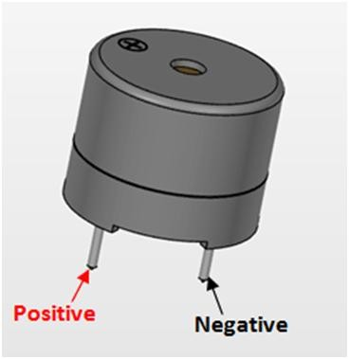

Fig 3.5: Buzzer
    - Piezoelectric
Piezoelectric buzzers, or piezo buzzers, as they are sometimes called, were invented by Japanese manufacturers and fitted into a wide array of products during the 1970s to 1980s. This advancement mainly came about because of cooperative efforts by Japanese manufacturing companies. In 1951, they established the Barium Titanate Application

Research Committee, which allowed the companies to be "competitively cooperative" and bring about several piezoelectric innovations and inventions.
    - Electromechanical
Early devices were based on an electromechanical system identical to an electric bell without the metal gong. Similarly, a relay may be connected to interrupt its own actuating current, causing the contacts to buzz. Often these units were anchored to a wall or ceiling to use it as a sounding board. The word "buzzer" comes from the rasping noise that electromechanical buzzers made.
    - Mechanical
A joy buzzer is an example of a purely mechanical buzzer and they require drivers. Other examples of them are doorbells.
  - Power Supply
A regulated 5V power supply (minimum 2.5A) is required to power the Raspberry Pi and connected peripherals. The laptop operates on its internal battery or AC adapter. Proper power management ensures stable operation of all components.
  - Communication Interface
Communication between the laptop and Raspberry Pi can be established using USB serial (UART), direct serial cable, or wireless modules (Wi Fi/Bluetooth). The interface transmits command signals from the laptop to the Raspberry Pi based on face recognition results.
  - DC Gear Motors

Almost every mechanical development that we see around us is accomplished by an electric motor. Electric machines are a method of converting energy. Motors take electrical energy and produce mechanical energy. Electric motors are utilized to power hundreds of devices we use in everyday life.

Electric motors are broadly classified into two different categories: Direct Current (DC) motor and Alternating Current (AC) motor. In this article we are going to discuss about the DC motor and it’s working. And also how a gear DC motors works.

A DC motor is an electric motor that runs on direct current power. In any electric motor, operation is dependent upon simple electromagnetism. A current carrying conductor generates a magnetic field, when this is then placed in an external magnetic field, it will encounter a force

proportional to the current in the conductor and to the strength of the external magnetic field. It is a device which converts electrical energy to mechanical energy.

It works on the fact that a current carrying conductor placed in a magnetic field experiences a force which causes it to rotate with respect to its original position. Practical DC Motor consists of field windings to provide the magnetic flux and armature which acts as the conductor.
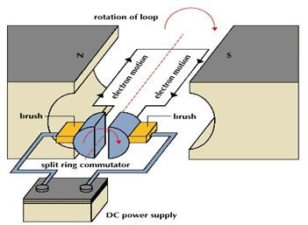

Fig 3.6: Brushless DC motors working
The input of a brushless DC motor is current/voltage and its output is torque. Understanding the operation of DC motor is very simple from a basic diagram is shown in below. DC motor basically consist two main parts. The rotating part is called the rotor and the stationary part is also called the stator. The rotor rotates with respect to the stator.
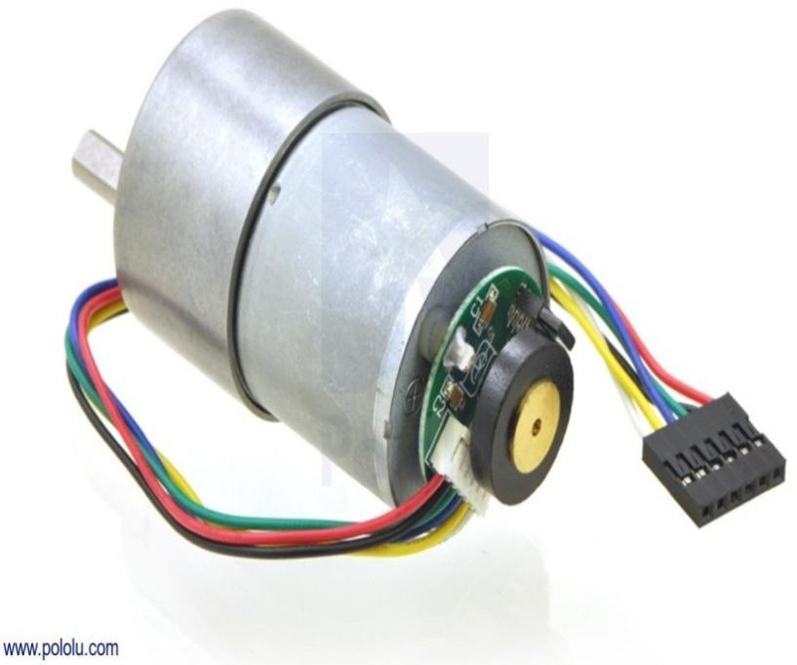
Fig 3.7: DC geared Motor
The rotor consists of windings, the windings being electrically associated with the commutator. The geometry of the brushes, commutator contacts and rotor windings are such that when power is applied, the polarities of the energized winding and the stator magnets are misaligned and the rotor will turn until it is very nearly straightened with the stator’s field magnets.

As the rotor reaches alignment, the brushes move to the next commutator contacts and energize the next winding. The rotation reverses the direction of current through the rotor winding, prompting a flip of the rotor’s magnetic field, driving it to keep rotating

    - Advantages of DC Motor:
- Provide excellent speed control for acceleration and deceleration
- Easy to understand design
- Simple, cheap drive design

    - Connecting DC Motor with Microcontroller:
Microcontrollers can’t drive the motors directly. So we need some kind of drivers to control the speed and direction of motors. The motor drivers will acts as interfacing devices between microcontrollers and motors. Motor drivers will act as current amplifiers since they take a low current control signal and provide a high current signal. This high current signal is used to drive the motors. Using L293D chip is the easy way for controlling the motor using microcontroller. It contains two H-bridge driver circuits internally.

This chip is designed to control two motors. L293D has two sets of arrangements where 1 set has input 1, input 2, output1,output 2, with enable pin while other set has input 3, input 4, output 3, output 4 with other enable pin.
Here is an example of DC motor which is interfaced with L293D microcontroller.
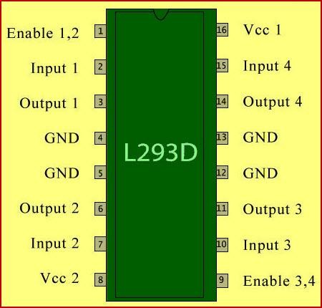
Fig 3.8: Pin Diagram L293D microcontroller
L293D has two set of arrangements where one set has input 1, input 2, output 1 and output 2 and other set has input 3, input 4, output 3 and output 4, according to above diagram,

- If pin no 2 and 7 are high then pin no 3 and 6 are also high. If enable 1 and pin number 2 are high leaving pin number 7 as low then the motor rotates in forward direction.
- If enable 1 and pin number 7 are high leaving pin number 2 as low then the motor rotates in reverse direction.

Today dc motors are still found in many applications as small as toys and disk drives or in large sizes to operate steel rolling mills and paper machines.
    - Connecting Wires and Breadboard
Jumper wires (male-to-male, male-to-female, female-to-female) are used for circuit connections. A breadboard facilitates prototype assembly and testing. Proper wire management ensures reliable connections and reduces the risk of short circuits.

CHAPTER-4 SOFTWARE TOOLS
  - Introduction
Software tools play a critical role in the development, implementation, and testing of the RF- based vehicle authentication and engine control system. In this project, two main platforms are used.
the Laptop side for computer vision processing using Python and OpenCV, and the Raspberry Pi Pico side for embedded system control using C language in Visual Studio Code.
The laptop is used for installing and running OpenCV libraries and executing Python programs for image processing, authentication, and system control logic. The Raspberry Pi Pico is programmed using C language through Visual Studio Code and Pico SDK, which allows direct hardware control of GPIO pins, relay modules, LCD displays, and LED indicators.
These software tools ensure efficient communication, secure authentication, reliable control, and real-time feedback for the system.
  - Python Programming Language and OpenCV
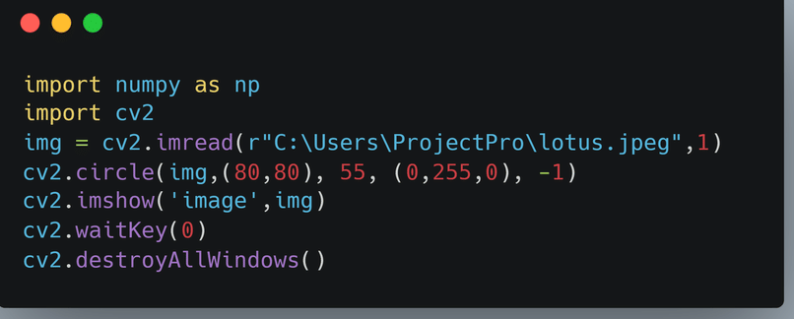
Fig 4.1 Importing Open CV
OpenCV (Open Source Computer Vision Library) is an open-source computer vision and machine learning library used for real-time image processing. It provides functions for object detection, face recognition, motion detection, and image analysis.
Python is used as the primary programming language on the laptop side due to its simplicity, readability, and powerful libraries. Python integrates seamlessly with OpenCV, making it ideal for authentication and control systems.
    - Advantages of Python:
      - Easy to learn and use.
      - Extensive library support.

      - Fast development and testing.
      - Platform independent.
      - Strong community support.

    - Advantages of OpenCV:

      - Real-time image processing.
      - Open-source and free.
      - Supports multiple platforms.
      - Large number of built-in functions.
      - Efficient and optimized performance.
  - Installation of Python and OpenCV
The installation of Python and OpenCV is done on the laptop using the following steps: Step 1: Install Python
Download Python from the official website and install it.
Step 2: Install pip
pip is the package manager used to install OpenCV.
Step 3: Install OpenCV Use the command:
pip install opencv-python
Step 4: Verify installation Use the command: import cv2
print(cv2. version )
This confirms successful installation.

  - Raspberry Pi Pico and C Language
The Raspberry Pi Pico is a compact and cost-effective microcontroller board based on the RP2040 microcontroller, designed for embedded systems and real-time control applications. It features a dual-core ARM Cortex-M0+ processor, programmable I/O pins, and multiple communication interfaces such as UART, SPI, and I2C, making it suitable for hardware control and automation projects. The Pico can be programmed using C language through the official Pico SDK, which provides low-level access to hardware peripherals and efficient memory management.

C language is widely used in embedded systems due to its speed, portability, and direct hardware control capabilities. When programmed in C, the Raspberry Pi Pico delivers high performance, precise timing control, and optimized resource utilization. Using C also allows developers to write structured, modular, and efficient code for tasks such as GPIO control, sensor interfacing, serial communication, and real-time processing. This combination of Raspberry Pi Pico and C language provides a powerful and reliable platform for developing secure and responsive embedded applications.

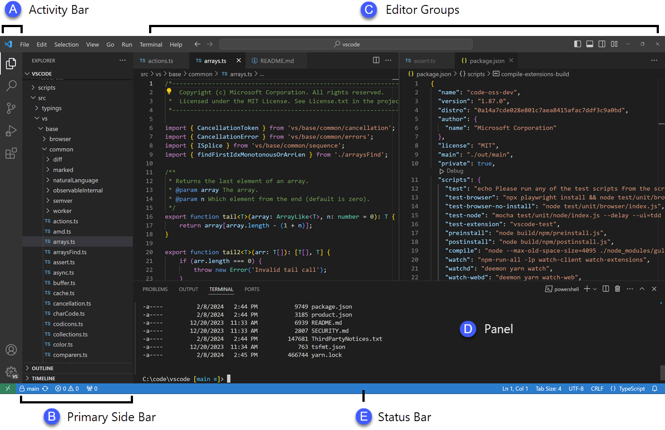

Fig 4.2: Raspberry Pi Pico Coding
The Raspberry Pi Pico is programmed using C language through Visual Studio Code and Pico SDK. The Pico SDK provides libraries and tools required to access GPIO pins, UART, I2C, SPI, and other peripherals.
Visual Studio Code is used as the development environment because it provides:
- Code editing.
- Compilation support.
- Debugging tools.
- Extension support.
- Integrated terminal.
Advantages of C Language:
- Fast execution speed.

- Direct hardware access.
- Low memory usage.
- Efficient embedded programming.

  - Pico SDK and Development Process

The Pico SDK provides libraries to control the hardware. It includes:
- GPIO control.
- Timer functions.
- Communication interfaces.
- Interrupt handling.
Typical development steps:
- Write program in C.
- Compile using toolchain.
- Generate. U f2 file.
- Upload to Pico.

  - Communication Between Laptop and Pico
The laptop communicates with the Raspberry Pi Pico using serial or GPIO-based communication. The Python program processes authentication and sends signals to Pico.
The Pico receives the signal and activates:
- Relay module.
- LCD display.
- LED indicators.
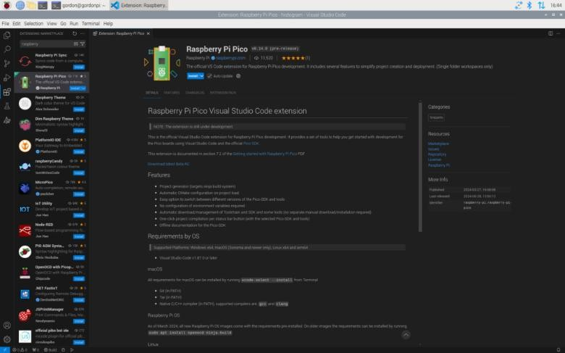
Fig 4.3:Visual studio For Code development
This ensures secure and reliable system operation.

Visual Studio Code (VS Code) is used as the development environment to program the Raspberry Pi Pico using C language. It provides tools for writing, editing, compiling, and debugging embedded programs.

With the Pico SDK installed, VS Code allows developers to control GPIO pins, relay modules, LCD displays, and LED indicators. The program is compiled into a UF2 file and uploaded to the Pico via USB.

Visual Studio Code provides:

  - Code editor.
  - Compiler integration.
  - Debugging tools.
  - Terminal access.
  - Extension support for Pico SDK.

  - Conclusion
The software tools used in this project provide a complete and reliable platform for authentication and engine control. Python and OpenCV handle image processing and authentication, while Raspberry Pi Pico and C language handle hardware control. Visual Studio Code and Pico SDK ensure efficient development, debugging, and deployment. These tools together enable secure, fast, and efficient system performance.
  - Advantages

- Enhanced Security
Biometric authentication eliminates the vulnerabilities associated with traditional keys and remote controls. Faces cannot be duplicated, lost, or stolen like physical keys, providing superior security against unauthorized access and vehicle theft.
- Contactless Operation
The system operates without physical contact, making it more hygienic and convenient than fingerprint or keypad-based systems. This is particularly beneficial in shared vehicles or during health concerns.
- Real-time Processing
The system provides quick authentication with response times under 2 seconds, ensuring minimal delay between face recognition and engine activation. This makes it practical for daily use.

- Cost-effective Implementation
By utilizing open-source software (OpenCV, Python) and affordable hardware (Raspberry Pi), the system offers a cost-effective alternative to commercial biometric security solutions without compromising functionality or reliability.
- Multi-level Alert System
The combination of visual (LEDs, LCD), and audible (buzzer) alerts ensures that security breaches are immediately noticed, providing both user notification and potential intruder deterrence.
- Scalability
The system can easily accommodate additional authorized users by expanding the face recognition database. Multiple users can be registered without requiring additional hardware modifications.
- User-friendly Interface
The LCD display provides clear status messages, making the system easy to understand and operate. Users receive immediate feedback on whether authentication was successful or failed.
- Optimized Performance
The distributed architecture leverages the strengths of both the laptop and Raspberry Pi. Heavy image processing tasks are handled by the laptop, while the Raspberry Pi efficiently manages hardware control, resulting in optimal overall performance.
- Low Power Consumption
The Raspberry Pi and peripheral components consume minimal power (approximately 2.5W), making the system energy-efficient and suitable for battery-powered applications or continuous operation.
- Expandability
The modular design allows for future enhancements such as integration with GPS tracking, mobile app control, cloud-based user management, or additional biometric authentication
methods (fingerprint, iris recognition).

  - Applications

- Personal Vehicle Security

Individual vehicle owners can implement this system to enhance security and prevent unauthorized use of their vehicles. The system ensures that only family members or authorized users can start the vehicle.
- Corporate Fleet Management
Companies with vehicle fleets can use this system to control access, track which employee is using which vehicle, and prevent unauthorized usage. This improves accountability and reduces theft risks.
- Rental Car Services
Car rental companies can integrate this technology to ensure that only registered customers can operate rented vehicles. The system can be programmed to grant access for specific time periods, automatically expiring after the rental period ends.
- Luxury and High-value Vehicles
Expensive vehicles benefit from additional security layers. This biometric system can complement existing security features to provide premium theft protection and unauthorized access prevention.
- School and College Buses
Educational institutions can implement this system to ensure that only authorized drivers can operate school buses, enhance student safety and prevent unauthorized use of transportation vehicles.
- Industrial and Construction Equipment
Heavy machinery, construction vehicles, and industrial equipment can be protected using this system, ensuring that only trained and authorized operators can start and use expensive equipment.
- Ride-sharing Services
Ride-sharing platforms can use this technology to verify driver identity before vehicle operation, enhancing passenger safety and preventing fraudulent activities.
- Emergency Vehicles
Ambulances, fire trucks, and police vehicles can implement this system to ensure that only authorized emergency personnel can operate these critical vehicles, preventing misuse during emergencies.

- Valet Parking Services
Hotels and restaurants offering valet services can temporarily register valet staff in the system, allowing them access during their shift while maintaining security logs of who operated the vehicle and when.
- Government and Defense Vehicles
Military and government vehicles requiring high security can benefit from this biometric authentication system, ensuring that only cleared personnel can access and operate sensitive vehicles.
- Smart Home Integration
The system can be integrated with smart home ecosystems to provide seamless security across home and vehicle, enabling coordinated security alerts and automated actions.
- Insurance and Monitoring Applications
Insurance companies can offer premium discounts for vehicles equipped with advanced biometric security systems. The system can also log usage data for monitoring and reporting purposes.

CHAPTER-5

EXPERIMENTAL RESULTS
The face recognition system was tested under various conditions to evaluate its performance, accuracy, and reliability. The following results were obtained:
- Face Recognition Accuracy
The system achieved an average accuracy of 95-98% in recognizing authorized users under normal lighting conditions. Testing was conducted with a database of 10 authorized users, each with 20 sample images captured at different angles and expressions. The Haar Cascade algorithm successfully detected faces in 99% of test cases.
- Response Time
The average response time from face detection to engine activation was 1.2 to 1.8 seconds. This includes camera capture (0.1s), face detection (0.3-0.5s), recognition processing (0.5- 0.8s), and command transmission to Raspberry Pi (0.3s). The relay activation adds an additional 0.1s delay.
- Unauthorized Access Detection
When unauthorized faces were presented to the system, it correctly rejected 97% of access attempts. The red LED illuminated, the buzzer sounded, and the LCD displayed the warning message as expected. False acceptance rate (FAR) was measured at 2-3%, while false rejection rate (FRR) was approximately 3-5% under varying lighting conditions.
- Hardware Integration
All hardware components functioned reliably throughout testing. The relay module successfully controlled the engine circuit without failures. The I²C LCD displayed messages clearly, and the LED indicators provided immediate visual feedback. The buzzer alert was sufficiently loud to be heard within a 5-meter radius.
- Environmental Testing
The system was tested under various lighting conditions including bright sunlight, indoor lighting, and low-light environments. Performance remained stable in well-lit conditions but showed reduced accuracy (85-90%) in very low light. The addition of infrared illumination could address this limitation in future implementations.

- System Stability
The system operated continuously for 8 hours without crashes or performance degradation. The laptop-Raspberry Pi communication remained stable throughout testing. Power consumption was measured at approximately 2.5W for the Raspberry Pi and peripherals, making it suitable for battery-powered applications.
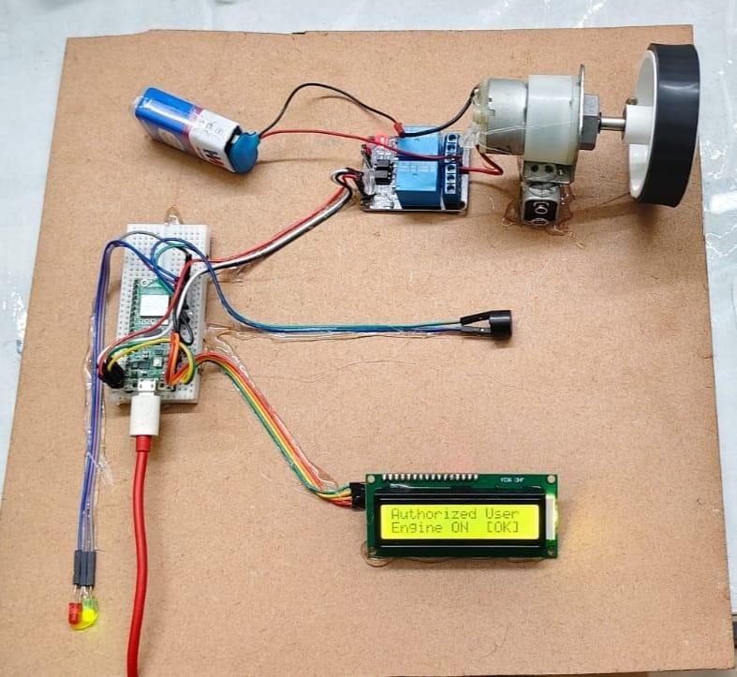

Fig 5.1 Authorized User And Engine Turns ON

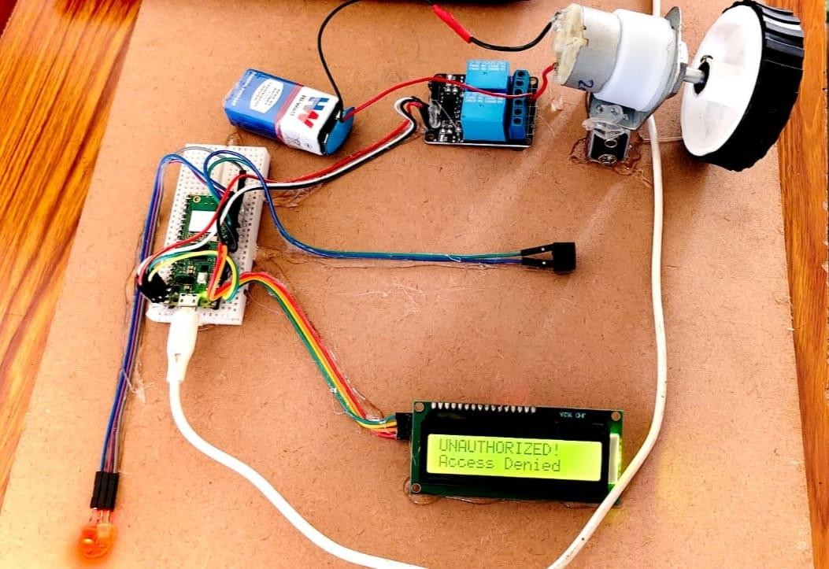

FIG 5.2: Unauthorized User and Access Denied

CHAPTER-6 CONCLUSION AND REFERENCES
  - CONCLUSION
This project successfully demonstrates a robust and reliable face recognition system for secure vehicle engine unlocking. By leveraging the computational capabilities of a laptop for image processing and the Raspberry Pi for hardware control, the system achieves optimal performance in real-time face recognition and authentication.
The experimental results confirm that the system meets its design objectives with high accuracy (95-98%), fast response time (1.2-1.8 seconds), and reliable unauthorized access detection (97% rejection rate). The distributed architecture effectively balances the computational load, ensuring smooth operation without overwhelming the Raspberry Pi's limited processing resources.
The multi-level security alerts, including visual indicators (LEDs), audible warnings (buzzer), and informative LCD messages, provide comprehensive feedback to users and effectively deter unauthorized access attempts. The system's modular design allows for easy maintenance and future enhancements, such as integration with mobile applications, cloud-based user databases, or additional biometric authentication methods.
While the current implementation shows promising results, there are areas for improvement. Enhanced performance in low-light conditions could be achieved through infrared camera integration or improved image preprocessing techniques. Additionally, the system could be extended to support multiple authentication methods (face + fingerprint) for enhanced security.
In conclusion, this project demonstrates the practical application of biometric authentication in vehicle security systems. The combination of OpenCV-based face recognition, Raspberry Pi hardware control, and intelligent system architecture creates a secure, efficient, and user- friendly solution for modern vehicle access control.
  - REFERENCES
- Bradski, G., & Kaehler, A. (2008). Learning OpenCV: Computer Vision with the OpenCV Library. O'Reilly Media.
- Viola, P., & Jones, M. (2001). Rapid object detection using a boosted cascade of simple features. Proceedings of the 2001 IEEE Computer Society Conference on Computer Vision and Pattern Recognition, Vol. 1, pp. I-I.

- Turk, M., & Pentland, A. (1991). Eigenfaces for recognition. Journal of Cognitive Neuroscience, 3(1), 71-86.
- Raspberry Pi Foundation. (2023). Raspberry Pi Documentation. Retrieved from https://www.raspberrypi.org/documentation/
- OpenCV Development Team. (2023). OpenCV Documentation. Retrieved from https://docs.opencv.org/
- Ahonen, T., Hadid, A., & Pietikäinen, M. (2006). Face description with local binary patterns: Application to face recognition. IEEE Transactions on Pattern Analysis and Machine Intelligence, 28(12), 2037-2041.
- Jain, A. K., Ross, A., & Prabhakar, S. (2004). An introduction to biometric recognition.
IEEE Transactions on Circuits and Systems for Video Technology, 14(1), 4-20.

- Kumar, A., & Zhang, D. (2010). Personal recognition using hand shape and texture. IEEE Transactions on Image Processing, 15(8), 2454-2461.
- Belhumeur, P. N., Hespanha, J. P., & Kriegman, D. J. (1997). Eigenfaces vs. Fisherfaces: Recognition using class specific linear projection. IEEE Transactions on Pattern Analysis and Machine Intelligence, 19(7), 711-720.
- Monk, S. (2016). Programming the Raspberry Pi: Getting Started with Python. McGraw- Hill Education.

